2023-2024

SPONSORSHIP OPPORTUNITIES FOR THE
Bulls Soccer Club
The Bulls Soccer Club, www.ga-scbulls.com is a non-profit 501(c)(3) Corporation. All donations are fully tax deductible. We currently have about 1200 families through the CSRA that we touch daily. We have an email database of over 2500 CSRA Families. The Club has boys and girls ages 4-19 involved in various aspects of soccer. We have a School of Excellence for children ages 4-12 that are not ready to play travel soccer but want the highest level of training and support. There are about 250-350 Players that attend that program from Columbia, Richmond, and Aiken County.
On our travel side, we have about 750 boys and girls playing U8- U19. These players are from all over the CSRA. We also host one of the most well-attended and successful Tournaments in the Southeast, The Columbia County Cup, www.aikensoccercup.org. The Columbia County Cup is one of the largest economic impact events in the CSRA. We bring in anywhere from 150-225 teams from all over the Southeast. We have even had teams from Canada attend the event. We fill up hotel rooms, restaurants, shopping malls, gas stations, and convenience stores from Columbia County to Aiken County. The Tournament is held at the outstanding Columbia County Parks and Recreation Facilities- Blanchard Woods Soccer Park and Patriots Park over the last weekend in August. This Tournament has received numerous awards and recognition throughout the CSRA for the Economic Impact it brings to the area. We also host a smaller tournament the last weekend of January, The Columbia County Spring Shootout, which has about 75-100 Teams. https://soccer.sincsports.com/dash.aspx?tid=BULLS&sinc=N&sic=N
The Marketing Audience
The Club offers an excellent opportunity to capitalize on growing soccer interest created by Atlanta United Professional Soccer, The Women's World Cup, Men's World Cup, the Olympics, the growing number of recreation players in the area, and the success of many of our high school teams in the area. The audience makes sponsorship an ideal vehicle for product and service marketing, and for image enhancement with the local community. The market is a middle to upper-class segment of the community with purchasing power and the disposable income available. Sponsorship is especially well suited for national and regional businesses located or thinking about locating in the CSRA because sponsorship demonstrates local support and involvement to participants from this area, but also provides impressions for visitors from other areas of the sponsor's marketing locations.
The direct audience includes about 1000 boys and girls ranging in age from 4 to 19: about 2200 parents, including coaches, managers, referees, and volunteers. The direct audience from the Columbia County Cup is about 3000 Players and at least 10,000 parents, plus siblings and other relatives, friends, and fans who attend as spectators. The indirect audience includes readers of Tournament publicity in the area and community newspapers; soccer coaches and administrators who see the Tournament's calendar listings and other promotional material in soccer publications; and parents and others who do not accompany their family's player, but who see the Tournament program and other materials both before and after the event.

Sponsorship Available
- Club and Tournament Sponsor
- CONTRIBUTION - $10,000 — Due by May 1 this ensures that your logo will get on uniform Jerseys
- $10,000 per year 2-year commitment, Total $20,000

BENEFITS - Sponsors Name on Tournament. Example: XYZ Columbia County Cup
- Sponsors Name on all Tournament T-Shirts-Approximately 1500 to be sold at the Tournament
- Sponsors Name on all Bulls Home and Away Uniforms
- Sponsors Name and Link on Bulls Website and Facebook, Twitter, and all social media • Sponsors Name and link on Columbia County Cup Website Facebook and Twitter and all social media
- Sponsors Name will be used in signage, at registration, and in printed promotional materials
- Monthly Social Media Post promoting your business to all our social media followers
- Sponsor may set up its own booth at fields or the Tournament headquarters for distribution of promotional materials. Size and location subject to Tournament approval; sponsor to provide booth personnel
- Sponsor may provide promotional materials for inclusion in registration materials distributed to competing teams and players

- Gold Sponsor- 12 AVAILABLE -Name and Logo on Training Gear 1400 Plus Shirts
- CONTRIBUTION - $2,500 Or In-Kind Trade
- Name and Logo on Club Training Jersey- Approx. 1600 Jerseys worn 3x a week • Company Banner at Tournaments -Provided by Company
- Name and Logo and Link to Company Website on Bulls Soccer Club Website • Name and Logo will be rotated with other sponsors on all Club Communication
- Sponsor may provide promotional materials for inclusion in registration materials
- Monthly Promotional emails
- Monthly Social Media Post promoting your business to all our social media followers
- Ability to set up booths and tables at any Bulls Events
- Dedicated email campaign to all our Bulls Emails

- Silver Sponsor $1,000 or in-kind trade
- Name and Logo and Link to Company Website on Bulls Soccer Club Website
- Name listed on Sponsor Banner at Soccer Fields
- Sponsor may provide promotional materials for inclusion in registration materials

- Bronze Sponsor $500 or in-kind trade
- Listing on Website as a Sponsor
- Name listed on Sponsor Banner at Soccer Fields
- Sponsor may supply promotional materials for inclusion in registration

- Patron Sponsors $100-$499
- Listing on Website as a Sponsor
- Sponsor may provide promotional materials for inclusion in registration materials distributed to competing teams and players

  - Tryout Sponsorship $3500 only 1 Available
- During Tryouts, each participant is given a tryout T-Shirt with a unique number on the t-shirt. In the past, we have had a corporate sponsor for these T-Shirts. We print about 900 of these, and your organization’s name will be prominently displayed on the tryout T-Shirt and all tryout materials, flyers, advertisements, and promotional material
- You will also have your business name/logo on all training tops. We have about two thousand training tops that the players wear three times a week
- Your business will be advertised on the Bulls Social Media Accounts Once Per Month
- You will also have a link on our website to your website

Exclusivity
Principal Name and presenting sponsors will be exclusive for their specific product or service category (e.g., grocery, athletic shoe/apparel maker, soccer store, hardware/home center, bank, etc.). This does not apply to age group sponsorships or program advertising.

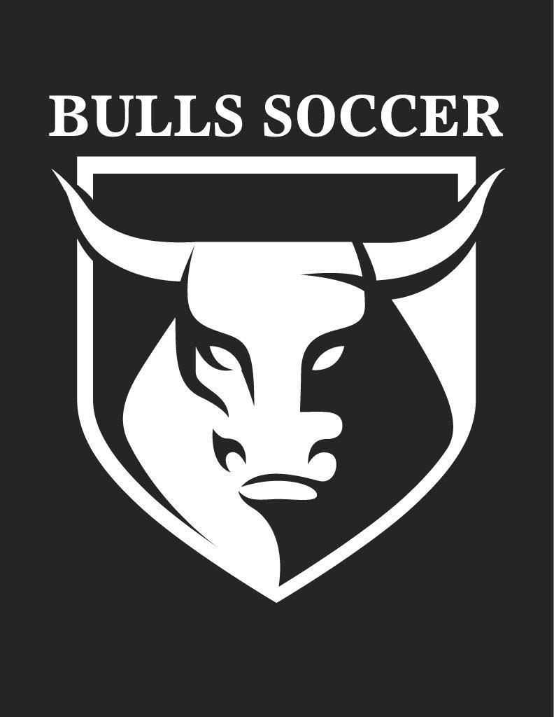

Bulls Soccer Club Sponsor Agreement Form

Name of Sponsor: ________________________________________
Contact name: __________________________________________
Phone: _______________________________________________
Address: _____________________________________________
Email Address: __________________________________________
Company Website: ______________________________________

Sponsorship Fees: Please Circle Your Choice of Sponsorship
1. Club and Tournament Platinum Sponsor $20,000
a. $10,000 Per Year 2-year agreement. 1st Payment due upon acceptance. Second Payment Due in 1 year
2. Gold Sponsor $2,500.00
3. Silver Sponsor $1,000.00
4. Bronze Sponsor $500.00
5. Patron Sponsor $_____________________
6. Tryout Sponsor $3,500.00
Total $ _____________
Please return this form along with your check and any camera-ready art to the Bulls Soccer Club. You can also email any Camera-Ready Artwork, Logos, Designs, Web links to bullssoccerkb@gmail.com. Please call the Bulls Soccer Club at (706) 550-2858 with any additional questions. Please make all checks payable to BULLS SOCCER CLUB.

Thank you for your support and we look forward to working with you.
Sincerely,
Andrew Hammer
Bulls Soccer Club
Executive Director

BULLS SOCCER CLUB
3685 Riverwatch Parkway Suite 145 Martinez, GA. 30907
(706) 550-2858 bullsadmin@ga-scbulls.com

